**Chatbot to Assist Online Shopping for Essentials During Pandemic Using Watson Assistant**

By. Dr. Nayana P. Mahajan

Category: IBM Cloud Application

Skills Required:  
ChatBot,IBM Watson Assistant, IBM Nodered

Project Description:

In today’s difficult times of Covid 19 Pandemic, with no medicine available, it is essential to maintain social distancing and avoid crowded places such as markets to protect against any viral infection. Therefore, it can be risky for some people to shop for essential items in person. Various online sites are available today for shopping from the comfort of our home.

This project helps with this issue by giving people an online option to shop for essentials. In this project a Chatbot, named Daily Needs Bot is built to assist customers in finding the essential items such as groceries and vegetables that they need. The Chatbot essentially works by providing an online chat box for the customers to post their enquiries / requirement of essential items and provides appropriate responses to customer queries and offers based on the inventory of items available in shop. The Chabot further helps in payments and delivery of items by capturing customer data.

This Chatbot is an IBM cloud application and has been built with the help of IBM Watson assistant.

**Services Used:**

1. IBM Watson Assistant
2. Node-Red

The user interface is built using Node-Red which interfaces with backend IBM cloud application (Watson Assistant) to provide online shopping platform for customers to shop for essential items.

**Architecture:**

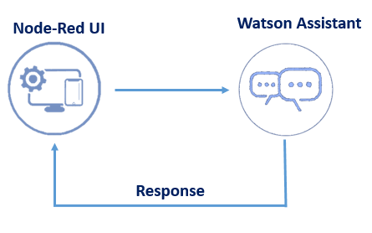

Daily Needs Bot has the following capabilities:

1. Give the list of items in the Store:

Daily needs BOT, (henceforth referred to as BOT in this document) first welcomes the online customer by saying “ Hi” or “ Good Morning/ Afternoon/ Evening” depending on the time of the day. The BOT then asks for customer details like name and email address, and the items to place the order The BOT then provides the list of fresh groceries and vegetable available. It shall also display the special items available for the customers

1. Should show the prices of vegetables

Along with the list of items / special items the BOT also provides the pricelist of the items.

1. Display if there are any offers or discounts

When asked by the customer, the BOT also displays the special offers available at that point of items along with the discounted prices against these offers. The BOT helps the customer to place the order by selecting the items required from the list. The BOT also asks for the quantity of each item to be purchased.

1. Placement of Order and Payment Processing

Upon order finalization of items, the BOT asks for the mode of payment such as COD/Card/ UPI to the customer. Finally the BOT provides the email conformation of the order to the customer.

cloud.ibm.com/login

After opening Watson assistant

<https://cloud.ibm.com/services/conversation/crn%3Av1%3Abluemix%3Apublic%3Aconversation%3Aeu-gb%3Aa%2Fd8d8881f8aeb403fa76adf69a66a8b54%3Ac7cdfa9d-c65b-477>

After launch Watson Assistant

<https://eu-gb.assistant.watson.cloud.ibm.com/eu-gb/crn:v1:bluemix:public:conversation:eu-gb:a~2Fd8d8881f8aeb403fa76adf69a66a8b54:c7cdfa9d-c65b-4770-aed3-e3f216f96bd2::/home>

Double click on Daily needs Bot and go to preview link

<https://web-chat.global.assistant.watson.cloud.ibm.com/preview.html?region=eu-gb&integrationID=0eef2025-25c3-45b3-88f6-667006cad54a&serviceInstanceID=c7cdfa9d-c65b-4770-aed3-e3f216f96bd2>

Questions and BOT response can be as below:

1. Customer: My name abc and my email ID is [123@gmail.com](mailto:123@gmail.com)

**BOT Response: Thank you for providing your name and gmail ID**

1. Customer: What are the special items?

BOT Response: Amul Ghee, Olive oil, Spinach By clicking any one it shows offer

1. **BOT Shows** List of fresh vegetables and groceries
2. Customer: I want to place an order

Olive oil

1. **BOT Response: How much Quantity?**

Customer: 2

1. **BOT Aks: Which is the payment modes COD, card, UPI?**

Customer: COD

1. **BOT Response: Thank you. Your order of olive oil is placed. Please pay your COD. Your receipt is send to 123@gmail.com** .

Enquiry and entities ate added:

<https://eu-gb.assistant.watson.cloud.ibm.com/eu-gb/crn:v1:bluemix:public:conversation:eu-gb:a~2Fd8d8881f8aeb403fa76adf69a66a8b54:c7cdfa9d-c65b-4770-aed3-e3f216f96bd2::/skills/f7a53c3c-e626-480f-9840-8a8edffa5278/build/intents>

Node – red application:

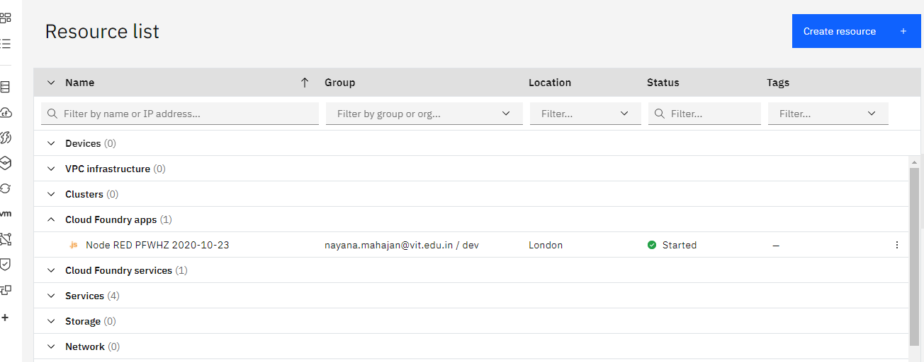

Node -red URL

<https://node-red-pfwhz-2020-10-23.eu-gb.mybluemix.net/red/?#flow/72a43412.4d854c>

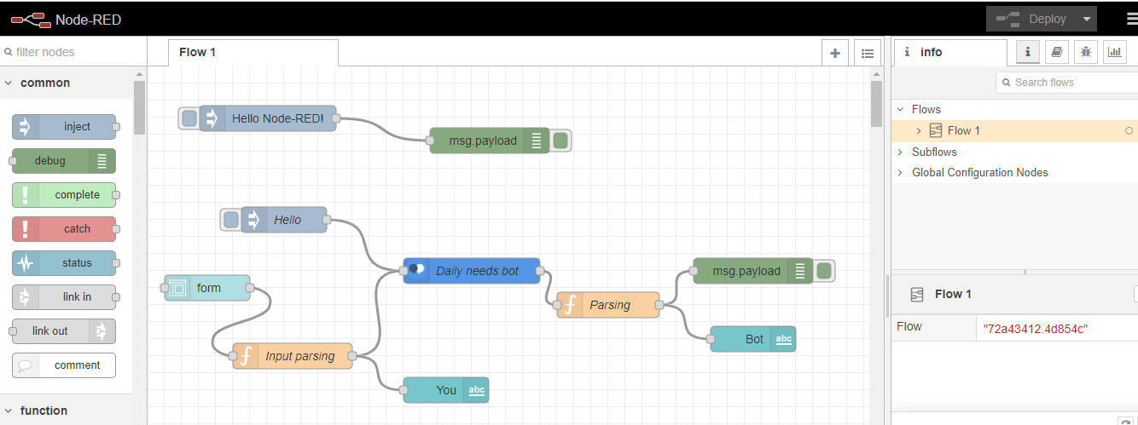

<https://node-red-pfwhz-2020-10-23.eu-gb.mybluemix.net/UI>

<https://node-red-pfwhz-2020-10-23.eu-gb.mybluemix.net/ui/#!/0?socketid=9SZa_95TduzSeDu6AAAH>

